LAB221Assignment | Type: | Long Assignment
 | Code: | J2.L.P0022
 | LOC: | 300
 | Slot(s): | 5

Title: Simple Calculator

Background
A simple calculator is a small program used to perform basic operations of arithmetic. It imitated hardware calculators by implementing the same functionality with mouse-operated, rather than finger-operated, buttons. Such software calculators first emerged in the 1980s as part of the Windows operating system.

Program Specifications
The simple calculator can perform basic arithmetic operations such as: Add, Subtract, Multiply and Divide Square root (√), %, and 1/x. The operands are positive/negative integer or decimal numbers.
It also supports:
- M+ add to value stored in memory,
- M- subtract from the value stored in memory,
- MR display the value in memory
- MC clear the value in memory
Features:
Add operation:
Input seq | Input | Display
1 | 1 | 1
2 | + | 1
3 | 2 | 2
4 | = | 3

Input seq | Input | Display
1 | 1 | 1
2 | + | 1
3 | 2 | 2
4 | + | 3
5 | 4 | 4
6 | = | 7
Subtract, Multiply, and Divide operations execute as the Add one.

Square root operation
Input seq | Input | Display
1 | 4 | 4
2 | √ | 2

Input seq | Input | Display
1 | 4 | 4
2 | +/- | -4
3 | √ | Error
1/x operation

Input seq | Input | Display
1 | 10 | 10
2 | 1/x | 0.1
% operation

Input seq | Input | Display
1 | 50 | 50
2 | % | 0.5

+/- operation

Input seq | Input | Display
1 | 3 | 3
2 | +/- | -3
3 | +/- | 3

M+, M-, MR and MC

M+
Input seq | Input | Display
1 | 1 | 1
2 | M+ | 1
3 | 2 | 2
4 | M+ | 2
5 | MR | 3
M-
Input seq | Input | Display
1 | 1 | 1
2 | M- | 1
3 | 2 | 2
4 | M- | 2
5 | MR | -3
M-, M+
Input seq | Input | Display
1 | 1 | 1
2 | M- | 1
3 | 2 | 2
4 | M+ | 2
5 | MR | 1
MC
Input seq | Input | Display
1 | 1 | 1
2 | M+ | 1
3 | MC | 1
4 | 2 | 2
5 | M+ | 2
6 | MR | 2

Expectation of User interface:
Go to http://www.online-calculator.com/ to have a deep understand of a simple calculator.

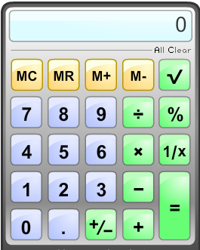
Clear the display, and reset the calculator

Guidelines
Use JFrame, JButton, JTextField, JLabel components and Math.sqrt() function.

